**IELTS Writing Task 1 Samples**

# Task 1 Sample Pie Chart

With pie charts you are usually given 2, 3, or 4 to compare. In this case there are 2.

## Task 1 Sample

You should spend about 20 minutes on this task.

**The pie chart shows the amount of money that a children's charity located in the USA spent and received in one year, 2016.**

**Summarize the information by selecting and reporting the main features and make comparisons where relevant.**

Write at least 150 words.

#### Revenue Sources and Expenditures of a USA Charity in one year, 2016.

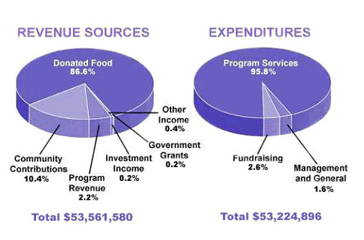

#### Model Answer

The pie charts show the amount of revenue and expenditures in 2016 for a children’s charity in the USA. Overall, it can be seen that donated food accounted for the majority of the income, while program services accounted for the most expenditure. Total revenue sources just exceeded outgoings.

In detail, donated food provided most of the revenue for the charity, at 86%. Similarly, with regard to expenditures, one category, program services, accounted for nearly all of the outgoings, at 95.8%.

The other categories were much smaller. Community contributions, which were the second largest revenue source, brought in 10.4% of overall income, and this was followed by program revenue, at 2.2%. Investment income, government grants, and other income were very small sources of revenue, accounting for only 0.8% combined.

There were only two other expenditure items, fundraising and management and general, accounting for 2.6% and 1.6% respectively. The total amount of income was $53,561,580, which was just enough to cover the expenditures of $53,224,896.

(161 Words)

## Comments

The response **achieves the task** because the data from the pie chart is selected and summarised appropriately.

Also, it can be seen that **comparisons are made**, which you are told to do in the rubric. The comparisons are clear from language such as 'similarly', 'much smaller', and 'largest revenue source'. Those are all language of comparison and contrast.

The summary is also **well-organised**. The writer decides first to compare the two largest items in each pie chart in the first paragraph, then go on to summarise the smaller items of expenditure, each in a separate paragraph.

It is therefore **easy to follow** the description.

There is not one right way to organise the pie chart. You could for example discuss each chart in turn as they are about different categories.

However, you should compare across categories if each pie chart is about the same thing.

## Task 1 Table for IELTS

Below is an IELTS Writing Task 1 Table. Below the table is a model answer.

With a table, you need to do much the same as you would for any other question that requires you to write about data.

In this case, the table is over time, so you would treat it like a line graph and describe the changes.

### Task 1 Table

You should spend about 20 minutes on this task.

**The table shows the Proportions of Pupils Attending Four Secondary School Types Between Between 2000 and 2009.**

**Summarize the information by selecting and reporting the main features and make comparisons where relevant.**

Write at least 150 words.

### 

### Secondary School Attendance

|  |  |  |  |
| --- | --- | --- | --- |
|  | **2000** | **2005** | **2009** |
| **Specialist Schools** | 12% | 11% | 10% |
| **Grammar Schools** | 24% | 19% | 12% |
| **Voluntary-controlled  Schools** | 52% | 38% | 20% |
| **Community Schools** | 12% | 32% | 58% |

### 

#### Model Answer

The table illustrates the percentage of school children attending four different types of secondary school from 2000 to 2009. It is evident that whereas the community schools experienced a marked increase in the proportion of those attending their institutions over the period, the others saw a corresponding decline.

To begin, the percentage of pupils in voluntary-controlled schools fell from just over half to only 20% or one fifth from 2000 to 2009. Similarly, the relative number of children in grammar schools - just under one quarter - dropped by half in the same period. As for the specialist schools, the relatively small percentage of pupils attending this type of school (12%) also fell, although not significantly.

However, while the other three types of school declined in importance, the opposite was true in the case of community schools. In fact, whereas only a small minority of 12% were educated in these schools in 2000, this figure increased to well over half of all pupils during the following nine years.

170 Words

### Comments

This task 1 table answer would get a good score for several reasons.

Firstly, there is a clear overview which points out the main trends:

It is evident that whereas the community schools experienced a marked increase in the proportion of those attending their institutions over the period, the others saw a corresponding decline.

It also meets the requirements of the task, as data is selected appropriately to describe some of the trends. Also, there are plenty of comparisons made between the data.

The data is organised clearly and coherently, in this case by firstly describing the schools that had a drop in attendance and then describing the one that saw on increase.

There is evidence of the ability to use some complex sentences and structures. For instance:

* whereas the community schools...
* the relatively small percentage of pupils attending this type of school (12%) also fell...
* while the other three types of school...

Also the writer in this task 1 table can write flexibly about numbers and change, for example:

* just over half to only 20% or one fifth from
* this figure increased to well over half of all pupils

## IELTS Map - Model Task 1 Answer

When you write about a map, you need to focus on describing where things are in location to each other.

Language such as 'to the left', 'next to', 'north of', 'behind' etc will be important.

### IELTS Map - Writing Task 1

You should spend about 20 minutes on this task.

**Below is a map of the city of Brandfield. City planners have decided to build a new shopping mall for the area, and two sites, S1 and S2 have been proposed.**

**Summarize the information by selecting and reporting the main features and make comparisons where relevant.**

Write at least 150 words.

#### Map of Brandfield with two proposed sites for a shopping mall

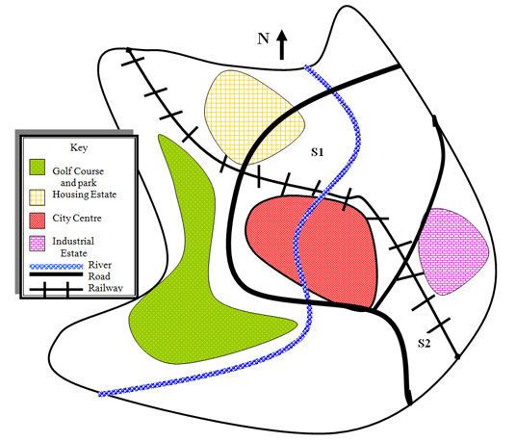

### 

### Model Answer

The map illustrates plans for two possible sites for a shopping mall in the city of Brandfield. It can be seen that the two sites under consideration are in the north and the south east of the town.

The first possible site for the shopping mall, S1, is just north of the city centre, above the railway line, which runs from the south east of the city to the north west. If it is built here, it will be next to a large housing estate, thus providing easy access for those living on the estate and in the city centre. It will also be next to the river that runs through the town.

The site in the south east, S2, is again just by the railway line and fairly close to the city centre, but it is near to an industrial estate rather than housing.

There is a main road that runs through the city and is close to both sites, thus providing good road access to either location. A large golf course and park in the west of the town prevents this area from being available as a site.

(190 words)

### Comments

Remember that when you have a map or process, you still need an **overview**. This IELTS map has one included:

It can be seen that the two sites under consideration are in the north and the south east of the town.

Missing an overview can limit you on Task Achievement to a band 5 so it's important to have one.

The map is **well-organised** as it first discusses the north of the city centre and then goes on to discuss the other site. Some further relevant information regarding location is then provided. It's always important to have a clearly organised Task 1.

With an IELTS map you need to have a good knowledge of the language of location, and there are several examples of this:

* just **north of** the city centre, **above** the railway line
* runs from **the south east** of the city **to the north west**
* **next to**
* site **in the south east**
* **close to** both sites
* **in the west** of the town

You need to also make sure you have a good mix of some complex sentences to get a band 6 or over for **grammar**, and there are several examples of words that create these:

* It can be seen **that**
* **which** runs from
* **If** it is   built here
* **that** runs through the town

## IELTS Process Diagram Sample

This page illustrates an example of an IELTS process.

Occasionally you will have to desribe a process in the test instead of a graph.

Although this type of diagram is less common to see in the test, it is still important to have an understanding of how to tackle this should it arise.

This is an example of the process of making bricks.

A sample answer is below the diagram.

### IELTS Writing Task 1

You should spend about 20 minutes on this task.

**The diagram illustrates the process that is used to manufacture bricks for the building industry.**

**Summarize the information by selecting and reporting the main features and make comparisons where relevant.**

Write at least 150 words.

#### The Brick Manufacturing Process

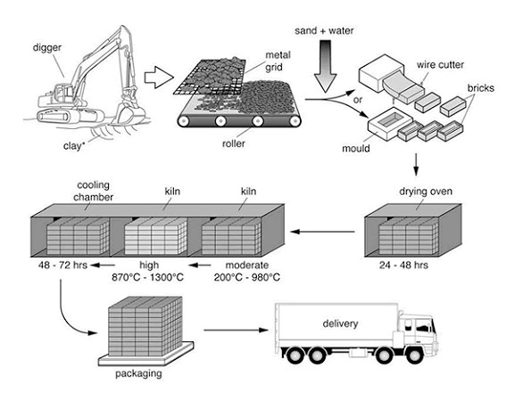IELTS Process Brick Manufacturing

[**135Save**](https://www.pinterest.com/pin/create/button/?guid=znhRhRHintoM-1&url=https%3A%2F%2Fwww.ieltsbuddy.com%2Fielts-process.html&media=https%3A%2F%2Fwww.ieltsbuddy.com%2Fimages%2Fielts-process-bricks.jpg&description=IELTS%20Process%20-%20Brick%20Manufacturing%20%0A%0AThe%20diagram%20illustrates%20the%20process%20that%20is%20used%20to%20manufacture%20bricks%20for%20the%20building%20industry.%0A%0ASummarize%20the%20information%20by%20selecting%20and%20reporting%20the%20main%20features%20and%20make%20comparisons%20where%20relevant.)

#### IELTS Process Model Answer

The diagram explains the way in which bricks are made for the building industry. Overall, there are seven stages in the process, beginning with the digging up of clay and culminating in delivery.

To begin, the clay used to make the bricks is dug up from the ground by a large digger. This clay is then placed onto a metal grid, which is used to break up the clay into smaller pieces. A roller assists in this process.

Following this, sand and water are added to the clay, and this mixture is turned into bricks by either placing it into a mould or using a wire cutter. Next, these bricks are placed in an oven to dry for 24 – 48 hours.

In the subsequent stage, the bricks go through a heating and cooling process. They are heated in a kiln at a moderate and then a high temperature (ranging from 200c to 1300c), followed by a cooling process in a chamber for 2 – 3 days. Finally, the bricks are packed and delivered to their destinations.

Words 173

### Comments

This is a good answer as it covers the requirements of the task.

The topic of the IELTS process diagram is first introduced and then an overview is given. You should give an overview for all academic task 1 responses, not just graphs.

In this case, here is the overview:

Overall, there are seven stages in the process, beginning with the digging up of clay and culminating in delivery.

The answer is well-structured, covering each stage of the process in turn.

It uses the [passive voice](https://www.ieltsbuddy.com/passive-voice.html) which is needed when you describe a process diagram in IELTS but you are not referring to who is doing the action. Here are some examples of the passive used:

* clay is then placed
* which is used to
* sand and water are added
* bricks are placed
* They are heated

## IELTS Sample Bar Chart

On this page you will find a model answer for an IELTS bar chart.

This chart is over time, so it uses the 'language of change'.

Have a look at this lesson for more advice on [describing a bar graph over time](https://www.ieltsbuddy.com/ielts-task-1.html).

### Gross Domestic Product in the UK

You should spend about 20 minutes on this task.

***The chart shows components of GDP in the UK from 1992 to 2000.***

***Summarize the information by selecting and reporting the main features and make comparisons where relevant.***

Write at least 150 words.

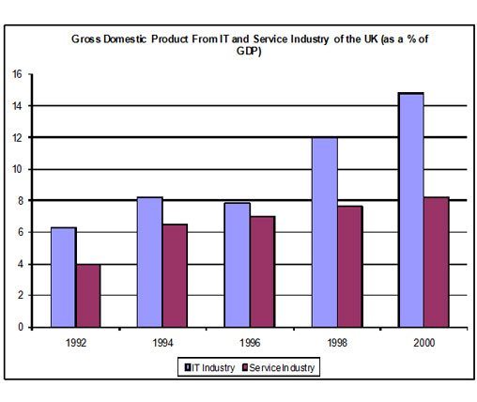IELTS Bar Chart - Components of GDP in the UK from 1992 to 2000

[**39Save**](https://www.pinterest.com/pin/create/button/?guid=0M8pZsKD76gv-1&url=https%3A%2F%2Fwww.ieltsbuddy.com%2Fbar-chart.html&media=https%3A%2F%2Fwww.ieltsbuddy.com%2Fimages%2Fielts-task-1-bar-chart-UK-G.jpg&description=IELTS%20Bar%20Chart.%20%0A%0AThe%20chart%20shows%20components%20of%20GDP%20in%20the%20UK%20from%201992%20to%202000.%0A%0ASummarize%20the%20information%20by%20selecting%20and%20reporting%20the%20main%20features%20and%20make%20comparisons%20where%20relevant.)

### Model Answer

The bar chart illustrates the gross domestic product generated from the IT and Service Industry in the UK from 1992 to 2000. It is measured in percentages. Overall, it can be seen that both increased as a percentage of GDP, but IT remained at a higher rate throughout this time.

At the beginning of the period, in 1992, the Service Industry accounted for 4 per cent of GDP, whereas IT exceeded this, at just over 6 per cent. Over the next four years, the levels became more similar, with both components standing between 6 and just over 8 per cent. IT was still higher overall, though it dropped slightly from 1994 to 1996.

However, over the following four years, the patterns of the two components were noticeably different. The percentage of GDP from IT increased quite sharply to 12 in 1998 and then nearly 15 in 2000, while the Service Industry stayed nearly the same, increasing to only 8 per cent.

At the end of the period, the percentage of GDP from IT was almost twice that of the Service Industry.

Words 182

### Comments

This answer meets the requirements of the task.

The introduction explains what the graph is about, and gives an overview of the main points.

The body paragraphs are ordered logically and clearly. The first body paragraph discusses the first three years, where the patterns are fairly similar. This is contrasted in the second body paragraph, where the GDP of each country diverges noticably.

There are a wide variety of sentence structures and the language of change is correctly used. The correct tense - the past - is used.

## ELTS Line Graph Examples

Continuing with the sites IELTS line graph examples, this is an example of a line graph comparing car theft.

It's important to organise your graph clearly, draw out the key trends and make comparisons.

That has been done well in this answer.

You should spend about 20 minutes on this task.

**The line graph shows thefts per thousand vehicles in four countries between 1990 and 1999.**

**Summarize the information by selecting and reporting the main features and make comparisons where relevant.**

Write at least 150 words.

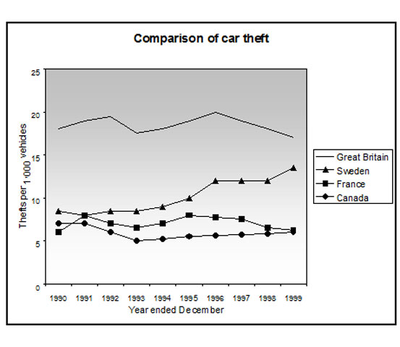Line Graph Examples - Comparisons of Car Theft

[**34Save**](https://www.pinterest.com/pin/create/button/?guid=meaQEpuPsdpD-1&url=https%3A%2F%2Fwww.ieltsbuddy.com%2Fline-graph-examples.html&media=https%3A%2F%2Fwww.ieltsbuddy.com%2Fimages%2Fielts-line-graph-cars.jpg&description=Line%20Graph%20Examples%20-%20Comparisons%20of%20Car%20Theft.%0A%0AThe%20line%20graph%20shows%20thefts%20per%20thousand%20vehicles%20in%20four%20countries%20between%201990%20and%201999.%0A%0ASummarize%20the%20information%20by%20selecting%20and%20reporting%20the%20main%20features%20and%20make%20comparisons%20where%20relevant.)

#### IELTS Line Graph Examples - Model Answer

The line graph compares the number of cars stolen for every 1000 vehicles in four countries from 1990 to 1999. Overall, it can be seen that car thefts were far higher in Great Britain than in the other three counties throughout the whole time frame.

To begin, car thefts in Sweden, France and Canada followed a fairly similar pattern over the first five years, all remaining at between 5 and 10 per thousand. The general trend though for France and Canada was a decline in the number of vehicles stolen over the period, with both at around 6 in 1999. In contrast, Sweden experienced an upward trend, starting the period at approximately 8, and finishing at just under 15.

Interestingly, car thefts in Great Britain started at 18 per thousand, which far exceeded that of the other countries. It then fluctuated over the next nine years, reaching a peak of 20 thefts per 1000 in 1996, and ending the period slightly lower than where it began, at approximately 17 per thousand.

(Words 174)

### Comments

This graph would score highly in the IELTS test.

The graph starts with an **overview** that highlights the key information presented in the graph.

It has also been **organised very clearly** around the main trends.

The first body paragraph describes Sweden, France and Canada together as they follow a very similar pattern, whereas Great Britain is discussed separately in the second body paragraph as this follows a very different pattern.

This makes the description **easy to follow and read** and shows the writer has been able to make **comparisons** of the data.

There is also a good range of vocabulary and accurate grammar.