Book: <https://bayanebartar.org/file-dl/library/IELTS2/IELTS-Trainer/IELTS-Trainer.pdf>

| **Date** | **Lesson content (Trainer pages)** | **Assign Speaking** | **Assign Writing** | **Assign Reading** |
| --- | --- | --- | --- | --- |
| wk 2 | test overview  LISTENING 1  LIST1 (p13) <https://www.youtube.com/watch?v=uQdGn6Ggs0c&list=PLcOVtLKIQzC7eN6DgB61cdg3K9Uqn6l-Q&index=7&ab_channel=GiangPh%E1%BA%A1m>  paraphrasing language signposts (p.14,21) | <https://www.youtube.com/watch?v=iT5dk3nkYfQ&ab_channel=E2IELTS>  prepare topics animals, communication |  |  |
| wk 3 | READING guidelines (p.23)  READING 1 pt1&2  scanning (30-31)  READING 1pt 3 Y,N,NG/ multiple choice | money, work |  |  |
| wk 4 | WRITING task 1 related language, p.40-45 **Bar Chart**  SPEAKING 1 + topics (work etc) | art, culture, education | Test 2 task 2 | T2 |
| wk 5 | discuss T2 writing 2  SPEAKING 2 + | health, food, family | Test 2 task 1 |  |
| wk 6 | discuss T2 writing 1 **Table**  T2 READING | environment, global issues | Test 3 task 2 | T3 |
| wk 7 | discuss T3 writing 2  SPEAKING 3 + | media, entertainment | Test 3 task 1 |  |
| wk 8 | discuss T3 writing 1 **Line Graph**  T3 READING | science & technology, space | Test 4 task 2 | T4 |
| wk 9 | discuss T4 writing 2  SPEAKING 4 + | sports, transport, | Test 4 task 1 |  |
| wk 10 | discuss T4 writing 1 **Line Graph**  T4 READING | travel | Test 5 task 2 | T5 |
| wk 11 | discuss T5 writing 2  SPEAKING 5 + | crime | Test 5 task 1 |  |
| wk 12 | discuss T5 writing 1 **Process Diagram**  T5 READING |  | Test 6 task 2 | T6 |
| wk 13 |  | - |  |  |

**LISTENING** Test 1

<https://www.youtube.com/watch?v=uQdGn6Ggs0c&list=PLcOVtLKIQzC7eN6DgB61cdg3K9Uqn6l-Q&index=7&ab_channel=GiangPh%E1%BA%A1m>

**LISTENING** Test 2

<https://www.youtube.com/watch?v=cFc3X6KY3KM&list=PLcOVtLKIQzC7eN6DgB61cdg3K9Uqn6l-Q&index=2&ab_channel=GiangPh%E1%BA%A1m>

**LISTENING** Test 3

<https://www.youtube.com/watch?v=HHpb0aV_xps&list=PLcOVtLKIQzC7eN6DgB61cdg3K9Uqn6l-Q&index=9&ab_channel=GiangPh%E1%BA%A1m>

**LISTENING** Test 4

<https://www.youtube.com/watch?v=yY9StBDrG5M&list=PLcOVtLKIQzC7eN6DgB61cdg3K9Uqn6l-Q&index=10&ab_channel=GiangPh%E1%BA%A1m>

**LISTENING** Test 5

<https://www.youtube.com/watch?v=LDHqbx0Gluo&list=PLcOVtLKIQzC7eN6DgB61cdg3K9Uqn6l-Q&index=11&ab_channel=GiangPh%E1%BA%A1m>

**LISTENING** Test 6

<https://www.youtube.com/watch?v=i1nk_HRqm3Q&list=PLcOVtLKIQzC7eN6DgB61cdg3K9Uqn6l-Q&index=12&ab_channel=GiangPh%E1%BA%A1m>

**LISTENING SCORES READING SCORES**

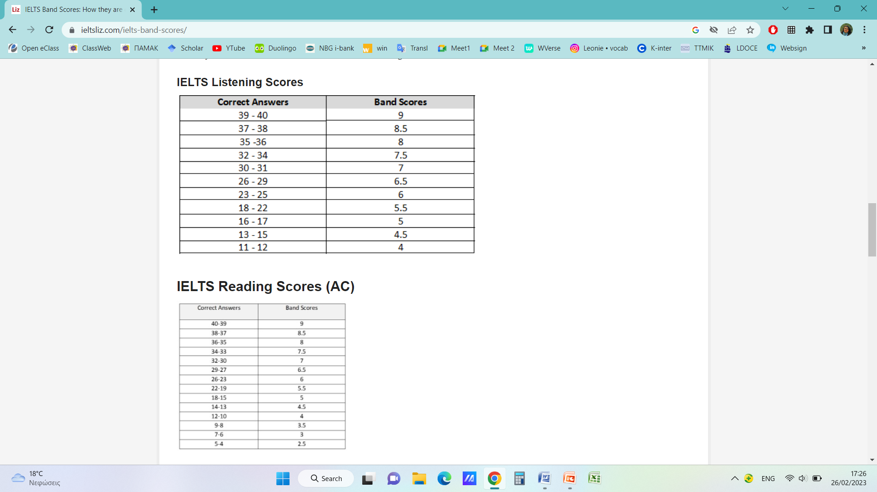

**OVERALL SCORE EXPLAINED**

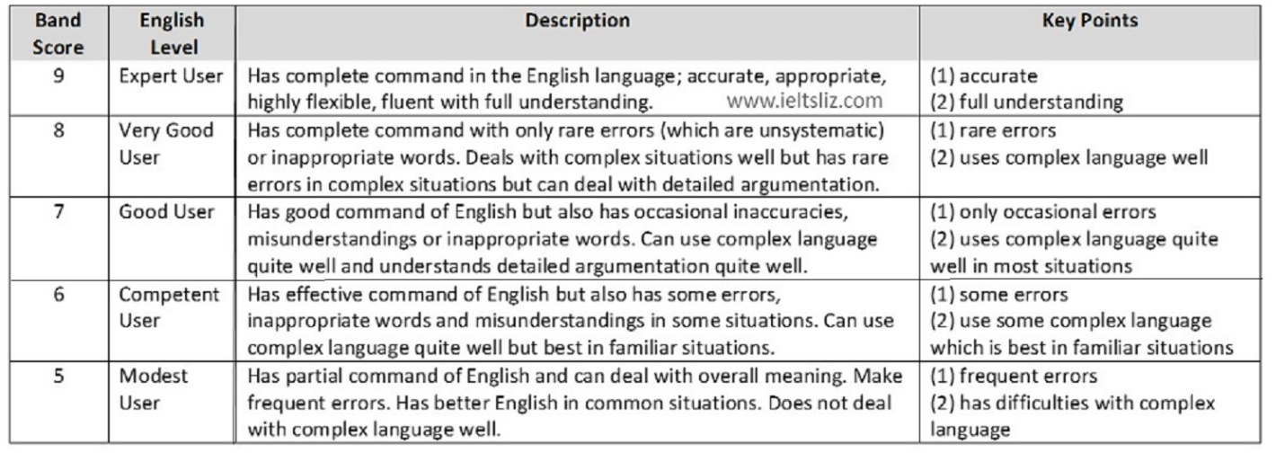

**Web resources for IELTS**

<https://www.ielts.org/about-the-test/sample-test-questions>

**Youtube channels**

IELTS Trainer https://www.youtube.com/playlist?list=PLcOVtLKIQzC7eN6DgB61cdg3K9Uqn6l-Q

E2 IELTS https://www.youtube.com/@E2IELTS

**Online resources (essays, vocabulary, test practice)**

https://www.ieltsbuddy.com/

**Essay samples**

https://docs.google.com/document/d/1bKt4PTizXh1A_9qes_MVGu6hCvSdbQJN/edit?usp=sharing&ouid=103241440996916826989&rtpof=true&sd=true

**Task 1/ Graph description samples**

https://docs.google.com/document/d/1aWA1yFc-SHz7VaWY0ODuewMcpgt53S37/edit?usp=sharing&ouid=103241440996916826989&rtpof=true&sd=true

**TIPS questions**

|  |  |
| --- | --- |
| **LISTENING** |  |
| * How many sections are there in the Listening part of the test? * How many times do you get to listen to each question? * What strategy is advised? |  |
| **READING** |  |
| * How many texts are there in the reading test? * How much time should you spend on each? * What is the basic piece of advice? * What types of reading are there? * When you look for the general idea * When you look for specific info |  |
| **SPEAKING** |  |
| * What should you look out for concerning your wording? * What is more important, correct responses or rich responses? * what guidance do cue cards and interviewers’ cues give you? |  |