From Anarchism and Other Essays (1910):
- “Marriage and love have nothing in common; they are as far apart as the poles; are, in fact, antagonistic to each other.”
- “I demand the independence of woman, her right to support herself; to live for herself; to love whomever she pleases, or as many as she pleases. I demand freedom for both sexes, freedom of action, freedom in love and freedom in motherhood.”
- 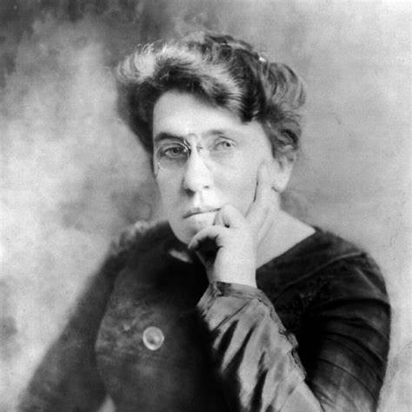
From The Traffic in Women (1910):
- “Woman’s development, her freedom, her independence, must come from and through herself. First, by asserting herself as a personality and not as a sex commodity. Second, by refusing the right to anyone over her body; by refusing to bear children unless she wants them; by refusing to be a servant to God, the State, society, the husband, the family, etc., by making her life simpler, but deeper and richer.”
From The Tragedy of Woman’s Emancipation (1906):
- “The history of woman is the history of man's cruelty and brutality to her.”
- “The emancipation of woman, as interpreted and practically applied today, has failed to reach her inner nature, to harmonize with her needs and aspirations. It has failed to bring her a deeper sense of happiness and contentment, her true release.”
- “The motto should not be: Forgive one another; rather, Understand one another.”
From The Hypocrisy of Puritanism (1910):
- “True emancipation begins neither at the polls nor in courts. It begins in woman’s soul.”
- “A true conception of the relation of the sexes will not admit of conqueror and conquered; it knows of but one great thing: to give one’s self boundlessly, in order to find oneself richer, deeper, better.”
From Mother Earth magazine (1906):
- “The woman who can create and foster life should have the first and highest claim to her own body, to the freedom and control of her reproductive faculties.”
From her essay Woman Suffrage (1910):
- “If voting changed anything, they’d make it illegal.”
- “True emancipation does not consist merely in a vote. True emancipation lies in the fact that woman is free, fully freed from the shackles of social and religious superstition, free from the dictates of fashion, public opinion, and the necessity of the marriage institution.”

PLEASE COMPARE THE QUOTES BY GOLDMAN WITH THE QUOTES BY LUXEMBURG TO BE FOUND BELOW:

On Women’s Role in Social Struggle
- “The working women of the entire world are with you. They are ready to support you in your heroic struggle. And one day, the millions of working women will tear down the rule of capitalist oppression with you and raise the flag of peace, freedom, and brotherhood high above a liberated humanity.”
  - Source: This is an adaptation from Luxemburg’s call for solidarity among the working class and was directed towards both men and women in her various letters and writings about the socialist movement.
2. On Women and Freedom
- “Those who do not move, do not notice their chains.”
  - Source: This quote is attributed to Luxemburg, though it's not from a specific essay or letter. It reflects her overarching philosophy found in many of her writings, such as Reform or Revolution (1900).
3. On the Socialist Women’s Movement
- “The proletarian women’s movement is both a class movement and part of the broader struggle of socialism for liberation. It has no special or different goal from the proletariat as a whole. Women, no less than men, suffer under capitalism and wage exploitation.”
  - Source: Luxemburg made similar statements about the unity of class struggle in her letters and speeches; this specific phrasing is adapted from her correspondence and speeches on socialism and the proletarian struggle (1912).
4. On Economic Emancipation
- “The emancipation of the working class from wage slavery and the emancipation of women from social and economic dependence are two aspects of the same struggle.”
  - Source: This is a synthesis from her writing in Social Reform or Revolution (1900) and from her contributions to socialist discussions on women’s role in economic independence within the broader labor movement.
5. On Women in Revolution
- “History is the only true teacher, the revolution the best school for the proletariat. Only in the revolutionary struggle does the working class, men and women alike, come to know who they are, what power they have, and what they can do.”
  - Source: The Russian Revolution (1918), where Luxemburg discusses the role of class struggle and revolution in awakening political consciousness.
6. On Universal Suffrage
- “The women’s question and the suffrage question are inseparable parts of the larger political movement of the working class. We are not fighting only for the political rights of women but for the full and equal political and economic rights for all oppressed people.”
  - Source: Writings on women’s suffrage and socialism from The Social Democracy and the Woman’s Vote (1912), published in the journal Die Gleichheit.
7. On Solidarity and Class Unity
- “As women, we have no separate cause from men. Our liberation is their liberation; our fight is their fight.”
  - Source: This reflects Luxemburg’s philosophy across various writings and speeches, especially in her correspondence and critiques of bourgeois feminism that separated women’s rights from broader class issues, often cited in her political essays on class struggle.
These sources reflect Luxemburg’s consistent focus on linking women’s issues to class struggle, with her ideas expressed across different works and correspondence.

