**Reading text**

Maslow's (1943, 1954) *hierarchy of needs* is a motivational theory in psychology comprising a five tier model of human needs (later (1970) expanded to an 8 stage model), often depicted as hierarchical levels within a pyramid. […]

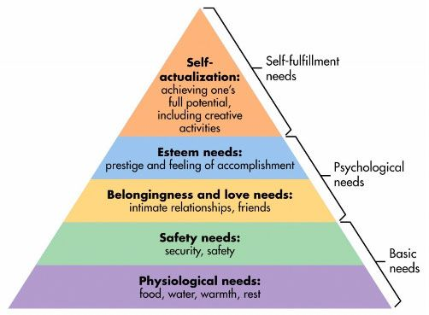

This five stage model can be divided into deficiency needs and growth needs. The first four levels are often referred to as deficiency needs (*D-needs*) and the top level is known as growth or being needs (*B-needs*). The deficiency needs are said to motivate people when they are unmet. Also, the need to fulfil such needs will become stronger the longer the duration they are denied. For example, the longer a person goes without food, the more hungry they will become.

One must satisfy lower level deficit needs before progressing on to meet higher level growth needs. When a deficit need has been satisfied, it will go away. Our activities become habitually directed towards meeting the next set of needs that we have yet to satisfy. These then become our salient needs. However, growth needs continue to be felt and may even become stronger once they have been engaged. Once these growth needs have been reasonably satisfied, one may be able to reach the highest level called *self-actualization*.

The original hierarchy of needs five-stage model includes:

1. Biological and Physiological needs - air, food, drink, shelter, warmth, sex, sleep.

2. Safety needs - protection from elements, security, order, law, stability, freedom from fear.

3. Love and belongingness needs - friendship, intimacy, trust and acceptance, receiving and giving affection and love. Affiliating, being part of a group (family, friends, work).

4. Esteem needs - achievement, mastery, independence, status, dominance, prestige, self-respect, respect from others.

5. Self-Actualization needs - realizing personal potential, self-fulfillment, seeking personal growth and peak experiences.

**Self-actualization**

The growth of self-actualization (Maslow, 1962) refers to the need for personal growth and discovery that is present throughout a person’s life. In self-actualization a person comes to find a meaning to life that is important to them. For some people self-actualization can be achieved through creating works of art or literature, for others through sport, in the classroom, or within a corporate setting.

It is important to note that self-actualization is a continual process of becoming rather than a perfect state one reaches of a 'happy ever after' (Hoffman, 1988). And, although we are all, theoretically, capable of self-actualizing, Maslow (1970) estimated that only 2% of people will reach the state of self actualization. He was particularly interested in the characteristics of people whom he considered to have achieved their potential as persons.

**Reading te**xt: McLeod, S. A. (2016). Maslow's Hierarchy of Needs. Retrieved from [www.simplypsychology.org/maslow.html](http://www.simplypsychology.org/maslow.html)