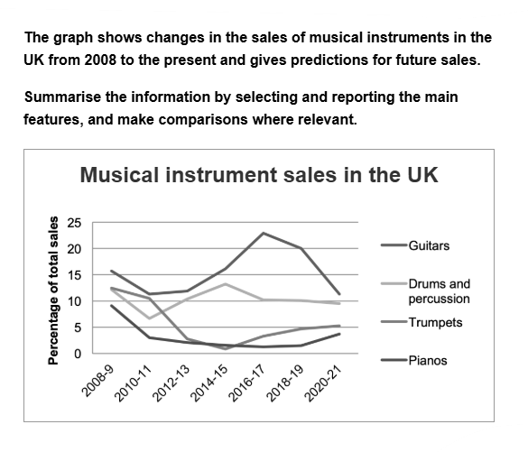
The graph illustrates the sales of four types of musical instruments (namely guitars, drums, trumpets and pianos) in the UK over time, from 2008 until today, while also including some projections as far as 2021.
Guitars were and are clearly projected to be the most popular instrument out of the four, while pianos are the least popular for the majority of the period. Trumpets began as the second most popular item until drums surpassed them in 2011, and left them at the 3rd spot.
Guitars sales specifically represented over 15% of the total sales in 2008 when they experienced a slight fall of 5% 2010-2011. After that, they gradually ascented to reach an all time high 22.5% at 2016-17. In the coming years, they are projected to drop back to the 2010-2011 levels. Conversely, pianos sales had a steady fall from under 10% in 2008 to a record low of approximately 2% in 2019. A mediocre increase (2%) is forecasted by the end of 2021.
Drums and trumpets both began at almost 12.5% of total sales in the beggining, while also both declined afterwards. While trumpets' sales fall was sharper, drums' was lengthier, as it reached a record low of 2% in 2015. The former reached a peak in the same year at 12.5 %. Lastly, both are expected to stabalise at 10% and 5% respectively.

Proofread for band 8:
Note:
1- Your vocabulary variety is of a high standard, I use different phrasing to suggest alternative ways of expressing the same things, eg. ‘a consistent downward trajectory/trend’
2- I spent quite a bit of time revising and tries a couple of options aiming for a decrease of word count.
Aim: include all necessary detail:
Trends: Upward, downward, fluctuating, stabilizing.
Key Figures: Starting, lowest, highest, and projected percentages for all four items.
Key Years: 2008, 2010-2011, 2015, 2016-2017, 2019, 2021.
Comparisons: Between the instruments.

The line graph illustrates the sales proportion of four musical instruments (guitars, drums, trumpets, and pianos) in the UK from 2008 to the present, with projections extending to 2021.

Overall, guitars remained the best-selling category throughout the period and are predicted to continue this trend, whereas pianos consistently accounted for the smallest market share.

More specifically, guitar sales began at just over 15% in 2008. After a mild 5% dip between 2010 and 2011, they rose to a peak of 22.5% around 2016-2017. A decline is projected by 2021, with sales expected to return to their 2010-2011 levels. In contrast, piano sales consistently dropped, from under 10% in 2008 to a record low of about 2% in 2019, with only a modest recovery of 2% forecast for 2021.

Drums and trumpets started the period at around 12.5%, but then experienced a decline, more prolonged for drums, more dramatic for trumpets. Drums bottomed out at 2% in 2015, while trumpets briefly rebounded to their initial 12.5%. Sales of both instruments are expected to stabilize in 2021, at 10% and 5% for drums and trumpets, respectively. (words: 184)

Score Estimate: 7
RUBRIC Criteria
- Task Achievement: 7
4 paragraphs: Introduction, Overview, 2 paragraphs for key details.
- Coherence and Cohesion: 7
Logical paragraphing, clear progression, good use of cohesive devices.
- Lexical Resource: 7
Good range, minor spelling errors.
Grammatical Range and Accuracy: 6
Mix of structures. Improve: proofread for persistent errors in articles, prepositions, and verb forms.
Examples of spelling issues/typos: ascented > ascended, beggining > beginning, stabalise should be stabilise/stabilize
Examples of unsuccessful collocations: lengthier fall > "more prolonged decline", mediocre increase >"modest/slight increase"
Examples of consistent grammatical errors that hinder clarity:
Article and Preposition Errors: "reach an all time high 22.5% at 2016-17" > in 2016-17 or between 2016 and 2017. "in the beggining" > at the beginning.
Missing words: "drums' was lengthier" > drums' fall was, “5% 2010-2011" > "5% from 2010 to 2011".

To aim for 8, focus should on improving grammatical accuracy (fixing the small but frequent errors) and polishing the occasional awkward phrasing ("mediocre increase," "were and are projected").

Length-related advice:
Rule: You must write at least 150 words. If you write less, you will be penalized on Task Achievement.
The Practical Reality (The ideal Limit): most high-scoring responses are between 160 and 190 words. Advantage of this:
  - Time Management: Task 1 should take 20 minutes. You need to leave adequate time for the more important Task 2 (40 minutes, 250 words minimum).
  - Risk of Repetition: you might include minor, irrelevant details or repeat information in different ways
  - Focus on Quality, Not Quantity: Examiners reward precise, accurate, and well-structured reporting over a lengthy description. Your skill is in selecting and highlighting key trends, not listing every data point.

