Writing Reference: Describing trends

- When we compare things (sales, turnover, profitability, etc), they can be either
  - The same, (e.g. This year’s sales were the same as last year’s; )
remained the same
maintained the same level OR
  - Similar (e.g. our company’s profitability was similar to others in the industry) OR
  - Different
e.g. This year, our sales were higher than last year’s
were not as low as
were not as many as
This year, our company indicated the highest turnover in the sector

- When we describe graphs we usually describe upward or downward trends.

A. Find verbs that describe upward and downward trends:
a. _________ __________
b. _________ __________
c. _________ __________
d. _________ __________
sudden upward and sudden downward trends
jump sink
soar plummet
_________ __________
_________ __________

Find adjectives and adverbs that modify change, show the degree and speed of the change recorded:

Degree of change |  | Speed of change
Adjectives | Adverbs | Adjectives | Adverbs
sharp |  | sudden

Numbers

Saying big numbers
We write | We say
1,200,464 | One million, two hundred thousand, four hundred and sixty-four
2,056,300 | Two million, fifty-six thousand, three hundred
56,311 | Fifty-six thousand, three hundred and eleven
200 | two hundred NOT two hundreds
1/4, 3/4 | one-quarter, three quarters
1/3, 2/3 | one third, two-thirds
1/2 | one-half
100 mph | One hundred miles per hour
212-555-1212 | two one two five five five one two one two
36° C (Celsius). | Thirty-six degrees Celsius
$43.35 | forty-three dollars and thirty-five cents, OR forty-three thirty-five
$120.50 | one hundred twenty dollars and fifty cents
 | Notice the point for decimals and the comma for thousands.

Expressions with numbers
- They’ve cut hundreds of thousands of pounds from the budget.
- Their assets alone must be worth in the tens of millions.
- I’m not sure what he earns, but it’s certainly a six-figure number.
- The number of emails waiting for me after my holiday was in triple figures.
- Expenditure increased nearly threefold between 1869 and 1871
- A grand = slang word for a $1,000 or £1,000
- A journey of a thousand miles begins with a single step.
- A picture paints a thousand words.
- to be one in a million
- to look/feel like a million dollars
- Thanks a million

Task: Practice saying these numbers
350
425
873
112
15,560
786,450
342,713
569,045
2,450,000
27,805,234
934,700,000
589,432,420
23,870,550,000
12,600,450,345,000
2.36
14.82
9.7841
3.14159
37%
12%
87%
3/8
5/16
7/8
1/32
$35.80
$175.50
4 7/8
23 1/2

You may also consult this BBC link for further listening practice in numbers: http://www.bbc.co.uk/learningenglish/english/course/intermediate/unit-25/session-1

Describing trends: practice

- Complete the description of the pie chart with your own words or phrases.

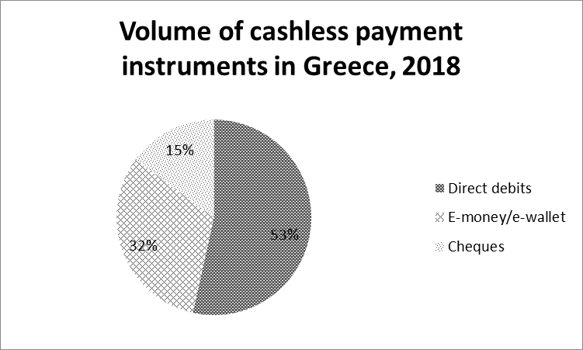
In 2018, the volume of direct debit on the customer’s account _____ that of other cashless payment instruments. In fact, it covers over _____ of the volume of cashless payments.
By contrast, cheque payments _____ only 15% of the total volume of cashless payments in Greece in 2018.
In the same year, the use of e-wallets seems to catch on as it represents almost one _____ of the volume of cashless transactions.

- Study the figure and complete the description.

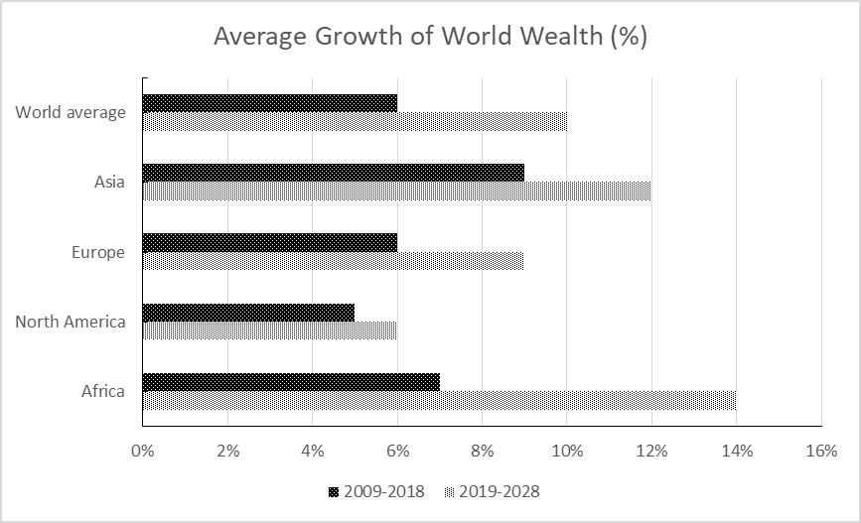
In this part of the description you need to complete the missing prepositions (as, at, between, by, from, in, to) plus two adverbs (a).
The bar graph indicates the increase ____ wealth ____ four continents as well ____ the world average ____ 2009 and 2018. It also projects the anticipated increase for the decade 2019 to 2028.
In the period ____ 2009 ____ 2018 the world average stood ____ 6%. Two continents that exceeded this rate ____ 3% and 1% (a)____ were Asia and Africa. Europe experienced a 6% increase, the same as that of the world overall, while the growth for N. America was (a)____ lower at 5%.
In this part of the description you need to complete the missing words on your own. If you find it difficult consult the box below.
Concerning future ____, the world average growth in wealth should ____ 10% in the decade 2019 to 2028. This is much higher than the rate ____ for N. America (6%) and slightly ____ than Europe’s rate of 9%. ____, Asia’s increase in wealth is expected to reach 12% and Africa is anticipated to ____ them all at 14% growth ____.
Al in all, the present growth rates of global wealth are expected to increase, but the increase will be most ____ in Asia and Africa.
In contrast, exceed, higher, predicted, projections, rate, reach, substantial

- For this graph/pie chart write your own description of the data on Internet usage frequency among individuals in Greece in 2018. Then, try to draw conclusions from these data in relation to the age of the population and the frequency of use.
Useful words or phrases:
Author’s thinking process | Level of certainty of the interpretation |  | Percentage of the sample
Verbs | Adverbs | Modal verbs | Noun phrases
Suggest  Imply  Conclude  Surmise (guess)  Be Related to | Most (un)likely  Probably  On a daily/weekly basis | Could  Might | The overwhelming majority

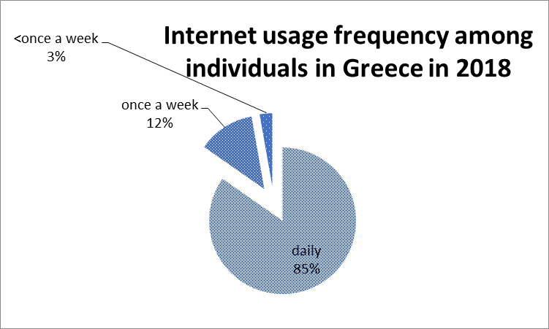
Your sentences
This graph suggests/ somehow verifies the fact that people that people of all ages make daily use of the internet. The 15% of the population who use it only once a week or less are most likely older people who cannot get accustomed to the new digital era.
Continue

- Guided writing
Study
- the bar chart below on the forecast number of mobile devices in use worldwide from 2020 to 2028 and
- the expected world population growth for 2020 (7.7 Billion) and 2028 (8 Billion).
Write 3-4 sentences describing the data from the chart and then compare the data from the chart with the predicted world population growth and finally draw some conclusions combining information from the two sources (e.g. number of devices per person, potential uses, etc.)
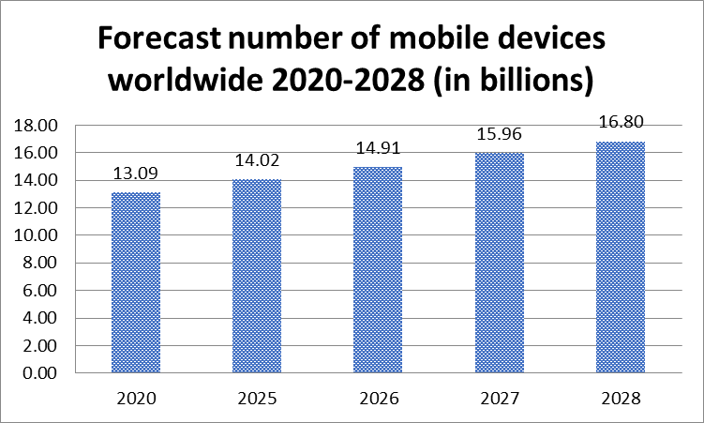

The bar chart shows ___________________
The number of mobile devices is forecast ________________________
World population is expected __________________________________
Continue…

- Write a paragraph describing the annual working hours of the average worker through the centuries.

Compiled by Juliet B. Schor, Wikipedia
TimeType of workerAnnual hours13th centuryAdult male peasant, UK1620 hours14th centuryCasual laborer, UK1440 hoursMiddle AgesEnglish worker2309 hours1400-1600Farmer-miner, adult male, UK1980 hours1840Average worker, UK3105-3588 hours1850Average worker, U.S.3150-3650 hours1987Average worker, U.S.1949 hours1988Manufacturing workers, UK1855 hours2000Average worker, Germany1362 hours

Self-study

- Study the figure and complete its description below with words and phrases from the box.

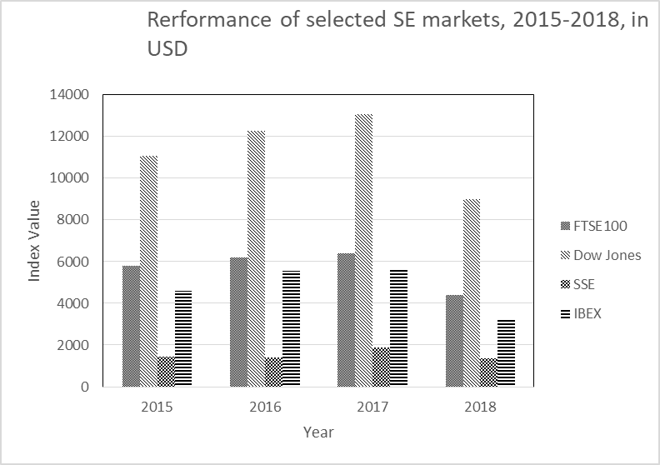

Comparison phrases (C): almost double, By contrast, compared to, more expensive, the highest, gradually increased,
Vocabulary (V): designated, depicts, notable, performance, transaction value, securities

The chart (V)_____ the performance of four stock exchange markets: two European (FTSE 100 in UK and IBEX in Spain), one American and one Asian over a four year period from 2015 to 2018.
The US stock exchange market seems to attract (C)_____ (V)_____ in the (V)_____ period. Its (V)_____ is (C) _____ that of the London stock exchange.
(C)_____, the Shanghai stock exchange indicated (C)_____ transaction value (C)_____ the other three stock exchange markets.
In the European context, the UK stock exchange market deals (C)_____ (V)_____ than the Spanish one.
Overall, the value of transactions (C)_____ from 2015 to 2017 in all four markets, while in 2018 there was a (V) _____ decline in their performance/ in the value of their transactions.

