This is a practice exam, provided with suggested answers for most of the questions, to help you prepare for the final exam. By learning how to approach and answer similar questions, you will be in a position to pass the course.
To achieve a higher mark, however, you will also need to answer some more challenging questions, which are not directly covered in this document.

Exercise 1
Consider the following payoff matrix:

 |  | Player 2
 |  | C1 | C2 | C3
Player 1 | R1 | 3, 3 | 0, 0 | 6, 1
Player 1 | R2 | 0, 0 | 4, 2 | 2, 0
Player 1 | R3 | 2, 1 | 1, 0 | 1, 2
Player 1 | R4 | 1, 0 | 0, 3 | 5, 5

- Clearly describe the game depicted in the payoff matrix above by reporting the players and their respective set of strategies.
This is a simultaneous-move, two-player game in normal form.
Player 1 chooses one of four strategies:
$$S_{1}=\{R1,R2,R3,R4\}.$$
Player 2 chooses one of three strategies:
$$S_{2}=\{C1,C2,C3\}.$$
Each cell gives the payoff pair $\left(u_{1} , u_{2}\right)$, where the first number is Player 1’s payoff and the second number is Player 2’s payoff.

- Are there any dominant and/or dominated (strictly or weakly) strategies for the players? Explain.
- For Player 1, compare the payoffs from each row. Player 1’s payoffs are:
$$R1=(3,0,6), R2=(0,4,2), R3=(2,1,1), R4=(1,0,5).$$
  - If we consider only pure strategies, there is no dominant strategy for Player 1, because no row gives Player 1 at least as much as every other row for all choices of Player 2.
  - However, $R4$ is weakly dominated by $R1$, because:
$$3>1,0=0,6>5.$$
So $R1$ gives Player 1 a higher payoff than $R4$ against $C1$and $C3$, and the same payoff against $C2$.
  - If mixed-strategy dominance is allowed, then $R3$ and $R4$ are strictly dominated by suitable mixtures of $R1$and $R2$. For example, a mixture placing probability $0.7$ on $R1$ and $0.3$ on $R2$ gives Player 1 payoffs:
$$(2.1, 1.2, 4.8),$$
which strictly dominate $R3=(2,1,1)$.

- For Player 2, compare the payoffs from each column:
$$C1=(3,0,1,0), C2=(0,2,0,3), C3=(1,0,2,5).$$
There is no dominant strategy for Player 2 and no pure strategy is strictly or weakly dominated by another pure or mixed strategy.

- Identify the Nash Equilbrium (or Nash Equilibria) in pure and in mixed strategies of the game. Fully explain your answer.
We identify best responses.
For Player 1:
- If Player 2 chooses $C1$, Player 1’s best response is $R1$, because $3>2>1>0$.
- If Player 2 chooses $C2$, Player 1’s best response is $R2$, because $4>1>0$.
- If Player 2 chooses $C3$, Player 1’s best response is $R1$, because $6>5>2>1$.
So:
$$BR_{1}(C1)=R1,BR_{1}(C2)=R2,BR_{1}(C3)=R1.$$
For Player 2:
- If Player 1 chooses $R1$, Player 2’s best response is $C1$, because $3>1>0$.
- If Player 1 chooses $R2$, Player 2’s best response is $C2$, because $2>0$.
- If Player 1 chooses $R3$, Player 2’s best response is $C3$, because $2>1>0$.
- If Player 1 chooses $R4$, Player 2’s best response is $C3$, because $5>3>0$.
So:
$$BR_{2}(R1)=C1,BR_{2}(R2)=C2,BR_{2}(R3)=C3,BR_{2}(R4)=C3.$$
A Nash equilibrium occurs when both players are best responding to each other. Therefore, the pure-strategy Nash equilibria are:
$$NE1=\left(R1 , C1\right)$$
with payoffs $(3,3),$ and
$$NE2=\left(R2 , C2\right)$$
with payoff $(4,2).$
For completeness, there is also a mixed-strategy Nash equilibrium in which Player 1 mixes between $R1$and $R2$, and Player 2 mixes between $C1$and $C2$:
$$P_{1}(R1)=\frac{2}{5},P_{1}(R2)=\frac{3}{5},$$
and
$$P_{2}(C1)=\frac{4}{7},P_{2}(C2)=\frac{3}{7}.$$

(the process of deriving these probabilities, i.e., MSNE, has been explained a lot in the class and there is material you can look for on eClass and it is not provided here!)

- Identify all the Pareto Efficient outcomes of the game. Explain.
An outcome is Pareto efficient if there is no other outcome that makes one player better off without making the other player worse off.
The outcome $\left(R4 , C3\right)$ gives payoffs:
$$(5,5).$$
This Pareto dominates many other outcomes, including $\left(R1,C1)=(3,3\right)$ and $\left(R2,C2)=(4,2\right)$.
The outcome $\left(R1 , C3\right)$ gives payoffs:
$$(6,1).$$
This is also Pareto efficient, because although Player 2 receives only $1$, Player 1 receives $6$, which is the highest payoff available to Player 1 in the matrix. No other outcome gives Player 1 at least $6$and Player 2 more than $1$.
Therefore, the Pareto efficient outcomes are:
$$\left(R1 , C3\right)$$
with payoff:
$$(6,1),$$
and
$$\left(R4 , C3\right)$$
with payoff:
$$(5,5).$$

- Is there a coordination failure problem in this game? Explain.

The pure-strategy Nash equilibria are:
$$\left(R1,C1)=(3,3\right)$$
and
$$(R2,C2)=(4,2).$$
Neither of these two Nash equilibria Pareto dominates the other. Player 1 prefers $\left(R2 , C2\right)$, while Player 2 prefers $\left(R1 , C1\right)$.
However, both pure Nash equilibria are Pareto dominated by $\left(R4,C3)=(5,5\right)$. Therefore, the game displays a broader coordination or efficiency problem: individually rational play may lead players to Nash equilibria that are not Pareto efficient.
So the answer is: yes, there is a coordination/efficiency problem, because the players fail to reach the Pareto superior outcome $\left(R4 , C3\right)$.

Exercise 2
Consider the game tree below describing a situation of strategic interactions.

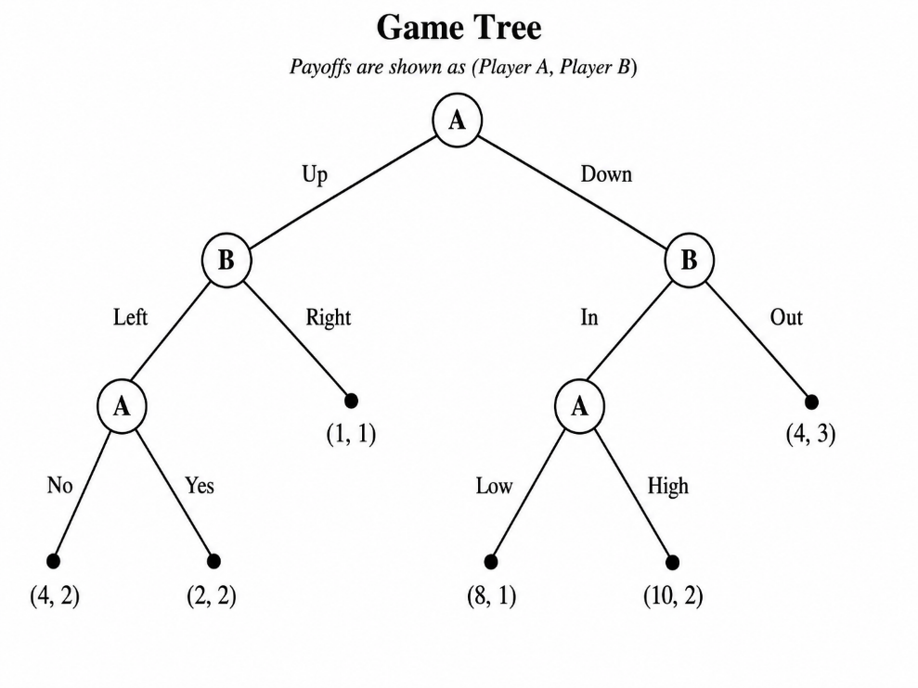
- What are the players and what are their respective strategy sets?
There are two players, $A \text{and} B.$ A strategy in an extensive-form game must specify what a player will do at every decision node at which that player may be called to move.
Player A has three decision nodes:
- At the initial node: $Up$ or $Down$.
- After $Up-Left$: $No$ or $Yes$.
- After $Down-In$: $Low$ or $High$.
Therefore, Player A’s pure strategies contain 3 actions and they are:
$$S_{A}=\{(Up,No,Low),(Up,No,High),(Up,Yes,Low),(Up,Yes,High), \\ (Down,No,Low),(Down,No,High),(Down,Yes,Low),(Down,Yes,High)\}.$$
The first component is A’s initial action, the second is A’s action after $Up-Left$, and the third is A’s action after $Down-In$.
Player B has two decision nodes:
- After $Up$: $Left$ or $Right$.
- After $Down$: $In$ or $Out$.
Therefore, Player B’s pure strategies contain two actions and they are:
$$S_{B}=\{(Left,In),(Left,Out),(Right,In),(Right,Out)\}.$$

- Clearly identify all the subgames (show by drawing proper lines on the game tree).

- Solve each subgame. Fully explain your answers.

We solve the game by backward induction.

SBG1: Subgame after $Up-Left$
At this node, Player A chooses between $No$and $Yes$.
If A chooses $No$, his payoff is $4$.
If A chooses $Yes$, his payoff is $2.$
Player A compares her own payoffs:
$$4>2.$$
Therefore, A chooses $No.$

Sbg2: Subgame after $Down-In$
At this node, Player A chooses between $Low$ and $High$.
If A chooses $Low$, his payoff is $8.$
If A chooses $High$, his payoff is $10.$
Player A compares her own payoffs:
$$10>8.$$
Therefore, A chooses $High.$

Sbg3: Subgame after $Up$
If B chooses $Left$, then A will later choose $No$, giving player B the payoff of $2.$
If B chooses $Right$, the game ends immediately with B’s payoff being $1.$
Player B compares:
$$2>1.$$
Therefore, B chooses $Left.$

Sbg4: Subgame after $Down$
If B chooses $In$, then A will later choose $High$, giving player B a payoff of $2.$
If B chooses $Out$, the game ends immediately with B’s payoff being $3.$
Player B compares:
$$3>2.$$
Therefore, B chooses $Out.$

Sbg5: Initial node
At the initial node, Player A compares the outcome from choosing $Up$ with the outcome from choosing $Down$.
If A chooses $Up$, player B will choose Left and player A will continue with No. Hence A will receive $4.$
If A chooses $Down$, player B will choose Out and so A receives $4.$
Player A is indifferent because:
$$4=4.$$
Therefore, both $Up$ and $Down$ are optimal at the initial node.

- What is (are) the SPNE? What is (are) the Backward Induction Outcome(s)?
The optimal continuation choices are:
- After $Up-Left$, A chooses $No$.
- After $Down-In$, A chooses $High$.
- After $Up$, B chooses $Left$.
- After $Down$, B chooses $Out$.
- At the initial node, A can choose either $Up$or $Down$.
Therefore, there are two subgame-perfect Nash equilibria.
First SPNE:
$$A=(Up,No,High),B=(Left,Out).$$
The backward-induction outcome is:
$$Up→Left→No,$$
with payoff:
$$(4,2).$$
Second SPNE:
$$A=(Down,No,High),B=(Left,Out).$$
The backward-induction outcome is:
$$Down→Out,$$
with payoff:
$$(4,3).$$
Because A is indifferent at the initial node, both outcomes are backward-induction outcomes.

Exercise 3
Consider the following strategic form Bayesian Game where player A has two types, namely type 0 with probability ¼ and type 1 with probability ¾ (as described by the payoff matrices below):
 |  | Player B
 |  | C1 | C2
Player A⁰ | R1 | 2, 1 | 0, 0
Player A⁰ | R2 | 1, 0 | 1, 1

 |  | Player B
 |  | C1 | C2
Player A¹ | R1 | 0, 0 | 2, 1
Player A¹ | R2 | 1, 1 | 0, 0

- What are the strategy sets of the two players?
Player A’s strategy must specify what each type of A would do. Type $A_{0}$ can choose $R1 \text{or} R2.$ Type $A_{1}$ can choose $R1 \text{or} R2.$ Therefore, Player A has four pure strategies:
$$(R1,R1),(R1,R2),(R2,R1),(R2,R2).$$
The first component is the action of type $A_{0}$, and the second component is the action of type $A_{1}$.
Player B’s strategy set is:
$$S_{B}=\{C1,C2\}.$$

- Prepare the unified payoff matrix and find its Nash Equilibrium (or Nash Equilbria).

The unified payoff matrix uses expected payoffs, taking into account that type $A_{0}$ occurs with probability $\frac{1}{4}$ and type $A_{1}$ occurs with probability $\frac{3}{4}$.
Let Player A’s strategies be:
$$s_{1}=(R1,R1), \\ s_{2}=(R1,R2), \\ s_{3}=(R2,R1), \\ s_{4}=(R2,R2).$$
The expected-payoff matrix is:
Player A strategy | C1 | C2
$$s_{1}=(R1,R1)$$ | $$\left(\frac{1}{2} , \frac{1}{4}\right)$$ | $$\left(\frac{3}{2} , \frac{3}{4}\right)$$
$$s_{2}=(R1,R2)$$ | $$\left(\frac{5}{4} , 1\right)$$ | $$\left(0 , 0\right)$$
$$s_{3}=(R2,R1)$$ | $$\left(\frac{1}{4} , 0\right)$$ | $$\left(\frac{7}{4} , 1\right)$$
$$s_{4}=(R2,R2)$$ | $$\left(1 , \frac{3}{4}\right)$$ | $$\left(\frac{1}{4} , \frac{1}{4}\right)$$
For example, for $s_{2}=(R1,R2)$ and $C1$, the expected payoff of Player A is:
$$\frac{1}{4}(2)+\frac{3}{4}(1)=\frac{1}{2}+\frac{3}{4}=\frac{5}{4}.$$
The expected payoff of Player B is:
$$\frac{1}{4}(1)+\frac{3}{4}(1)=1.$$

- Properly describe all Bayesian Nash Equilibria of the Game.
The pure-strategy Bayesian Nash equilibria are the same as the pure Nash equilibria of the unified game.
First BNE
$$A_{0}:R1,A_{1}:R2,B:C1.$$
This is a Bayesian Nash equilibrium because, given that B chooses $C1$:
- Type $A_{0}$ prefers $R1$ to $R2$, since:
$$2>1.$$
- Type $A_{1}$ prefers $R2$ to $R1$, since:
$$1>0.$$
Given A’s strategy $\left(R1 , R2\right)$, B prefers $C1$ to $C2$, since:
$$1>0.$$
So all players are best responding.

Second BNE
$$A_{0}:R2,A_{1}:R1,B:C2.$$
This is a Bayesian Nash equilibrium because, given that B chooses $C2$:
- Type $A_{0}$prefers $R2$to $R1$, since:
$$1>0.$$
- Type $A_{1}$prefers $R1$to $R2$, since:
$$2>0.$$
Given A’s strategy $\left(R2 , R1\right)$, B prefers $C2$to $C1$, since:
$$1>0.$$
So all players are best responding.

